KAUSHAMBHI

DEORIA

VARANASI

LUCKNOW

KANPUR NAGAR

BAREILLY

SONBHADRA

KANPUR DEHAT

LALITPUR

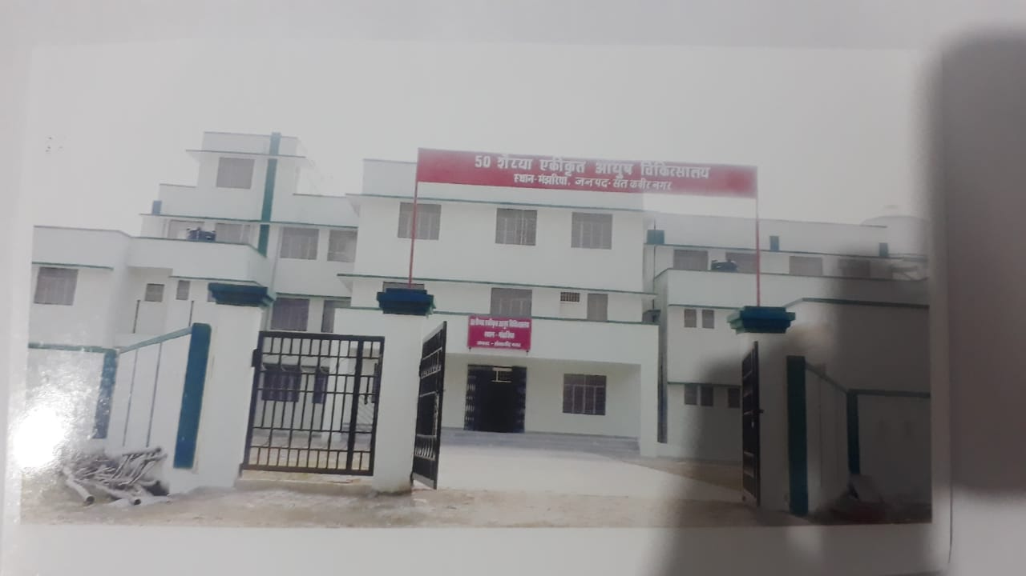SANT KABIRNAGAR

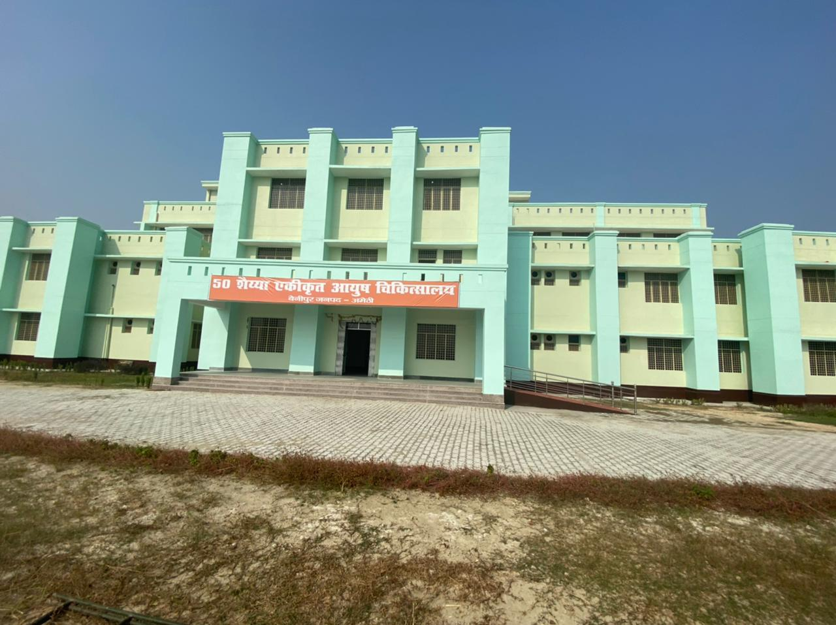

AMETHI

